CSCI 6406 Visualization – project proposal

**D3 Visualization Research and Implementation**

**The trends of new house price index in Canada**

Song Zhao B00694453

**Project objectives:**

Learn to use the D3 library to implement a specific dataset visualization. The visible data should help about solving the problems and making decision in the real world. In addition, by researching existing papers to find out the new ideas and use them to the project.

**Background:**

Many people dream they can own their own houses (including me). However, the price of house is very high. If people buy houses with bank loans at a wrong time, they have to pay more money. So, to estimate the trend of houses’ price accurately is very important. In this project, I am going to create a data visualization for new house price indexes of Canada in the past 10 years (2008-2018). As a reference to find a good stage to buy a house.

**Implementation steps:**

First, collecting and cleaning the data from statistics Canada. Then, researching the existing papers online to decide how to create the visualization program. Third, writing a program by using D3 with some specific algorithms to visible to dataset. Finally, finding valuable things from the data visualization and help decision-making.

**Techniques:**

Programming language: JavaScript, HTML, CSS.

Development IDE: Visual studio Code.

Library: D3

Visualization Styles: Interactive bar chart and pie chart.

**Resources for studying:**

A paper - Interactive HTML Reporting Using D3 [1]

The dataset of Statistic Canada [2]

DashBoard Tutorial [3]

D3 Stacked-to-Grouped Bars Tutorial [4]

More in future.

**Dataset:**

New housing price index from 2008 Jan to 2018 Dec from Statistics Canada

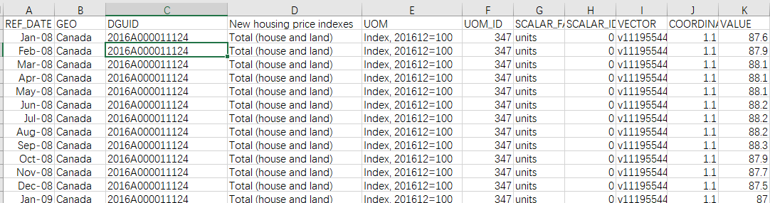

**Timeline:**

|  |  |
| --- | --- |
| Feb.2 – Feb.8 | Read papers, find topic, finish the proposal |
| Feb.9-Feb.15 | Find some new ideas base on the papers |
| Feb.16-Mar.8 | Work and finish the project update |
| Mar.9-Apr.1 | Work and finish the final project |
| Apr.2 -Apr.5 | Improve and Submit the project. |
| On schedule | Presentation for the project |

**Reference:**

1. Puliyambalath, N. (2014). Interactive HTML Reporting Using D3. Nationwide Insurance.
2. Statistic Canada [online] Available at:

https://www150.statcan.gc.ca/t1/tbl1/en/tv.action?pid=1810020501 [Accessed 8 Feb. 2019].

1. Bl.ocks.org. (2019). DashBoard. [online] Available at:

http://bl.ocks.org/NPashaP/96447623ef4d342ee09b [Accessed 8 Feb. 2019].

1. Beta.observablehq.com. (2019). D3 Stacked-to-Grouped Bars. [online] Available at: https://beta.observablehq.com/@mbostock/d3-stacked-to-grouped-bars [Accessed 8 Feb. 2019].